- Create VPC with 2 private and 2 public subnets.
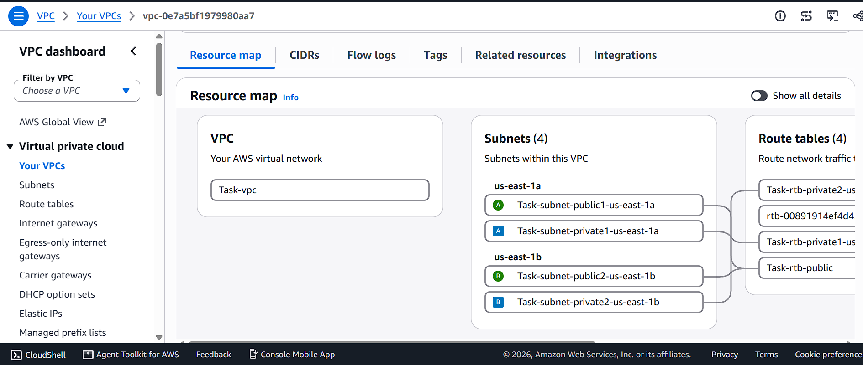
- Enable DNS Hostname in VPC.
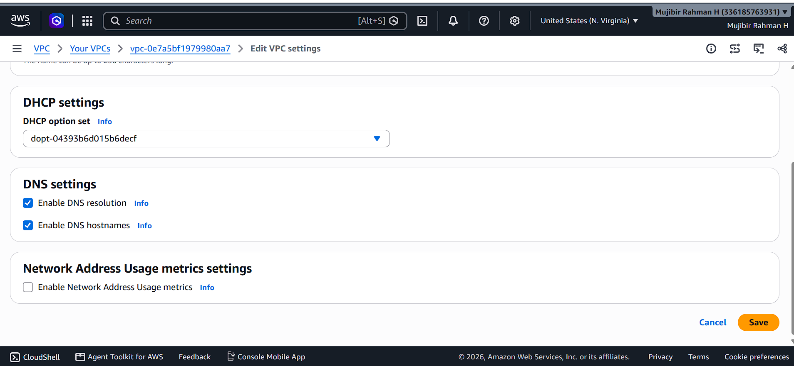
- Enable Auto Assign Public IP in 2 public subnets.
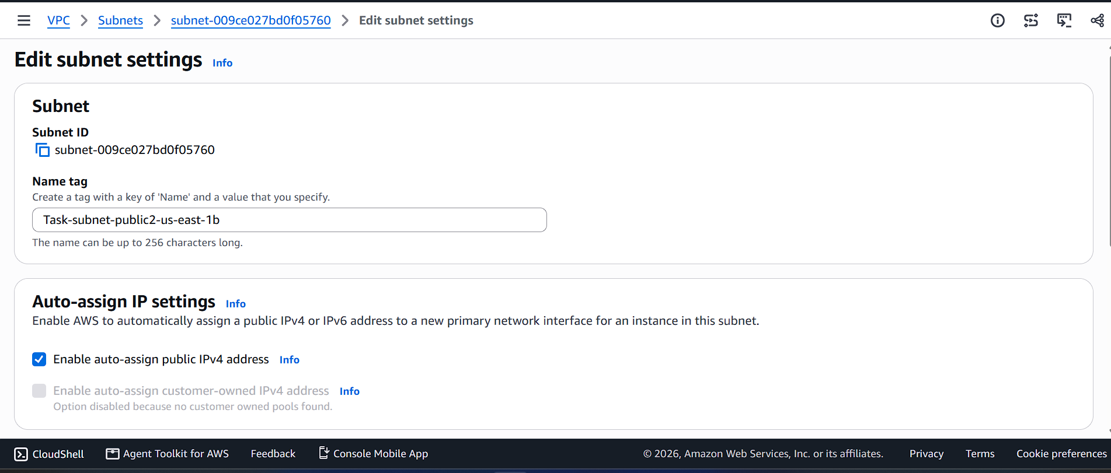
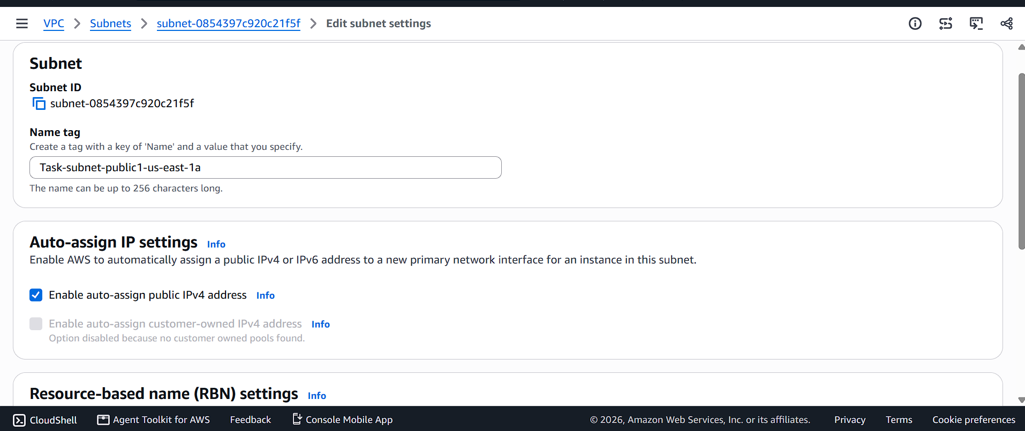
- Add 2 private subnets in private route table.
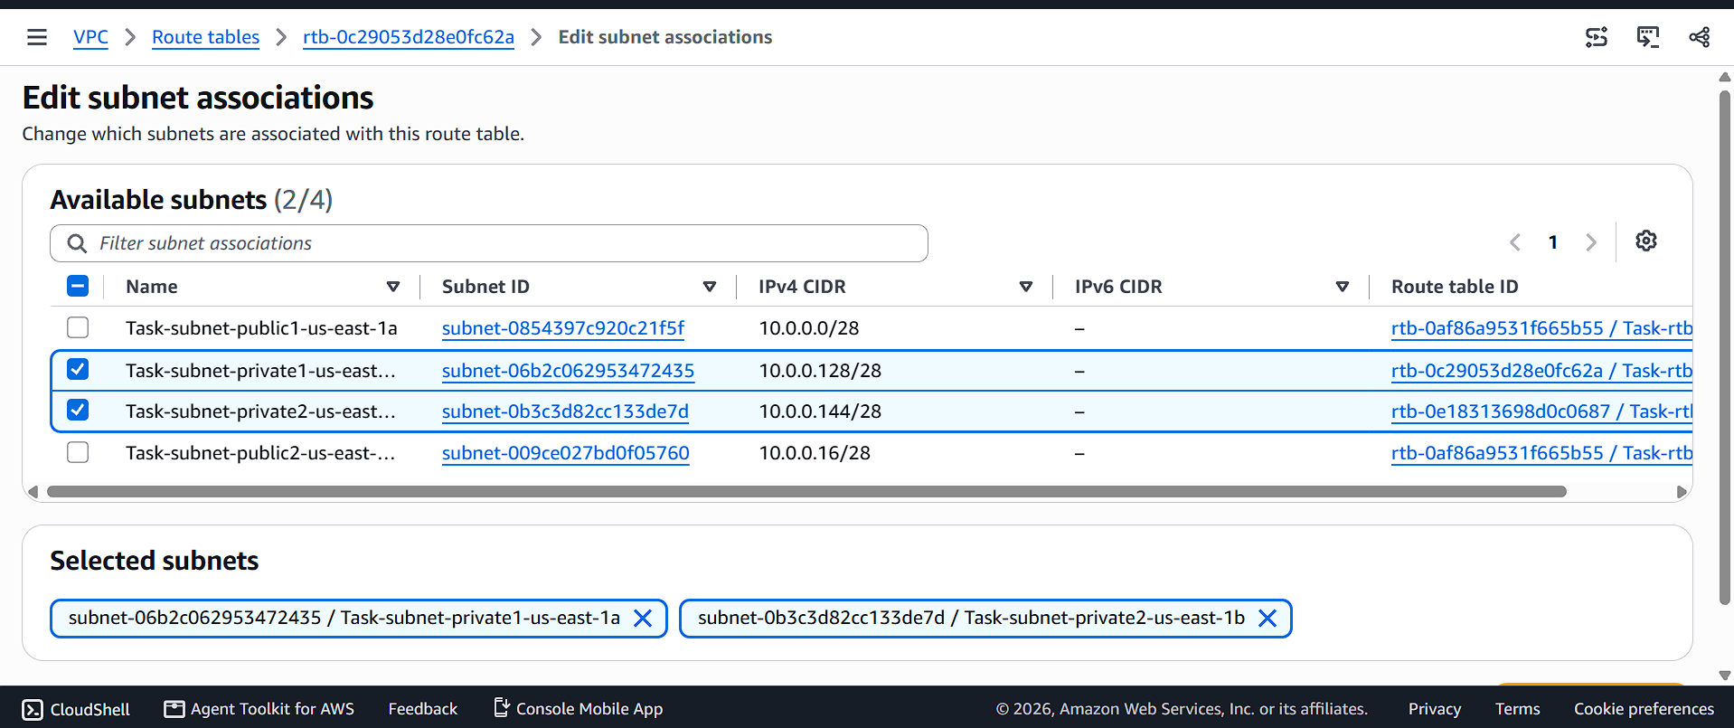
- Add 2 public subnets in public route table.
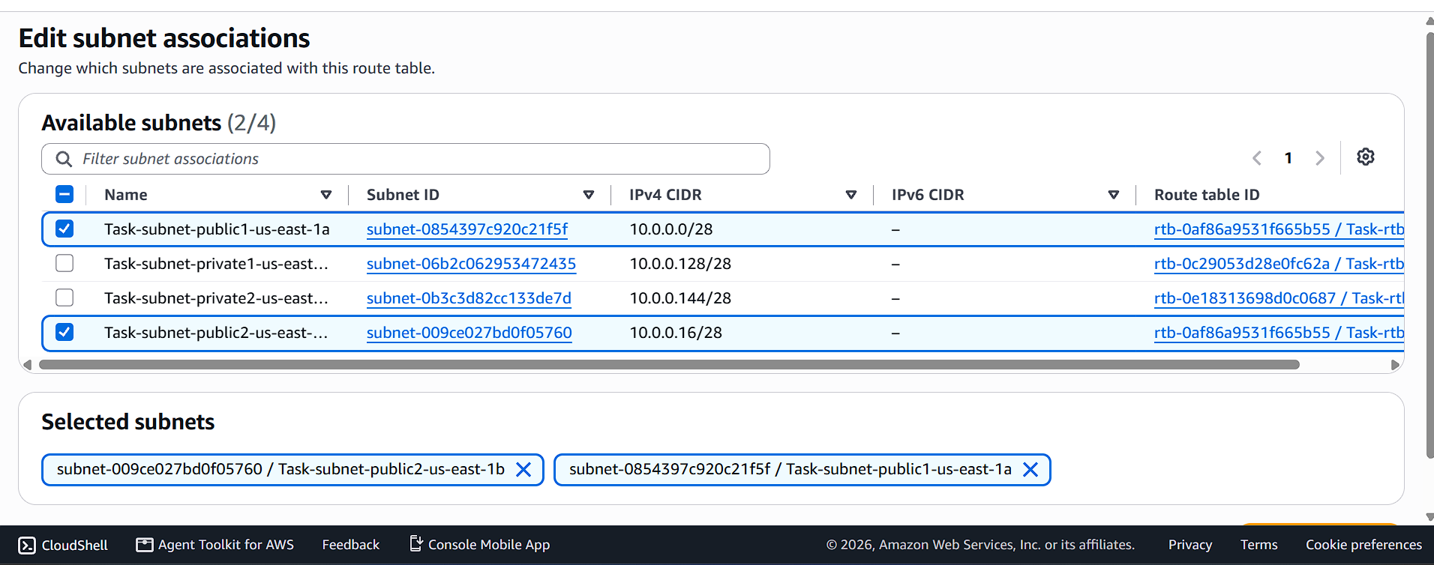
- Public route table will have the routes to internet and local.
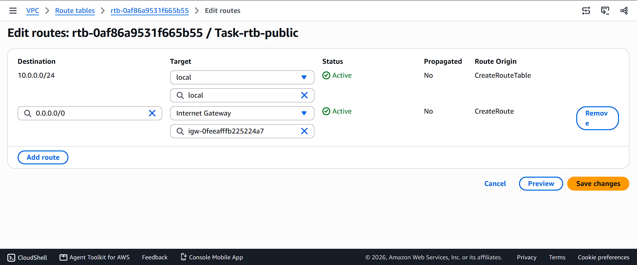
- Create EC2 in public subnet with t2.micro and install PHP.
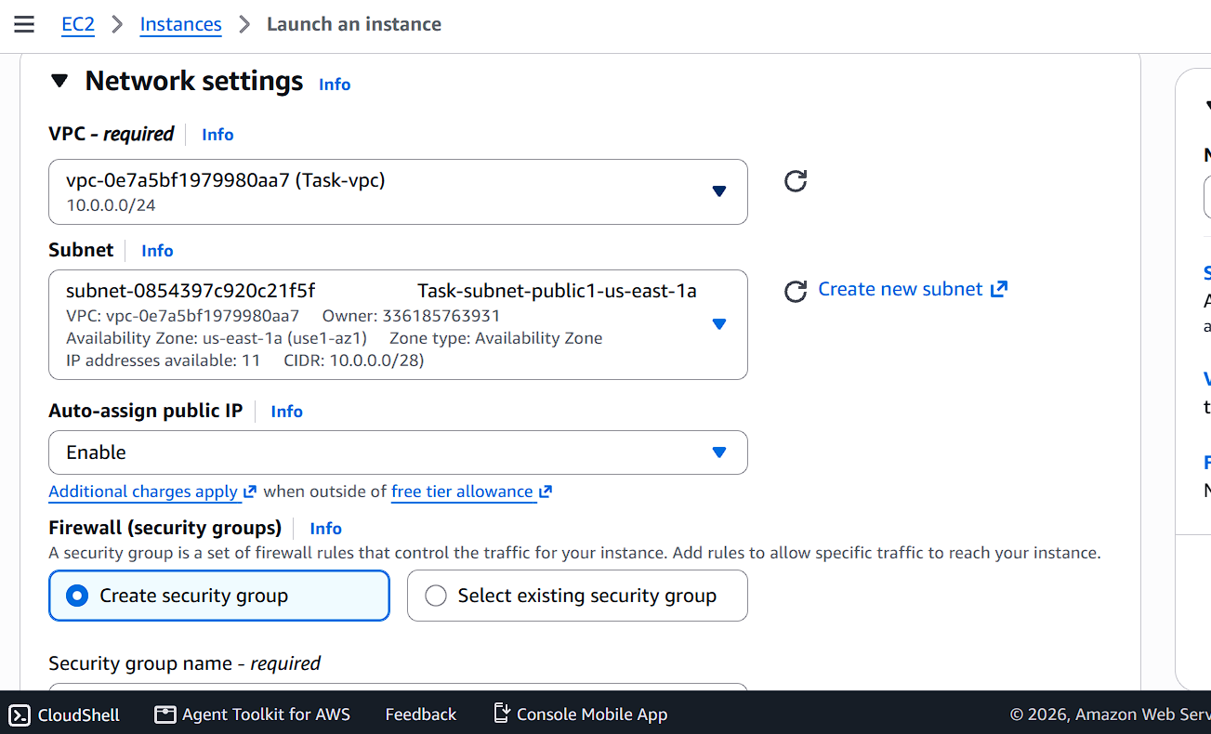
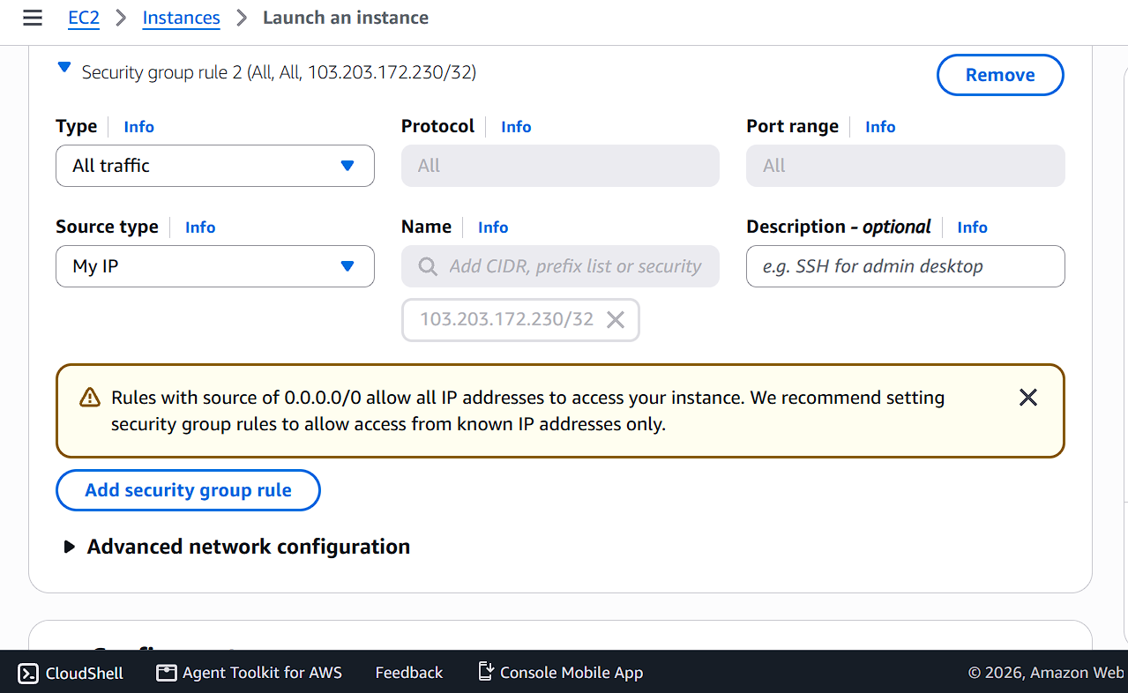
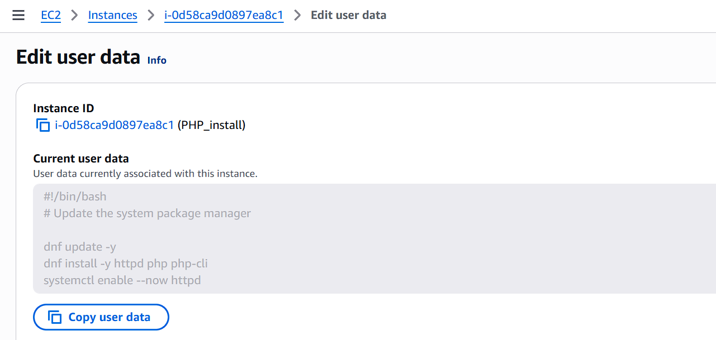
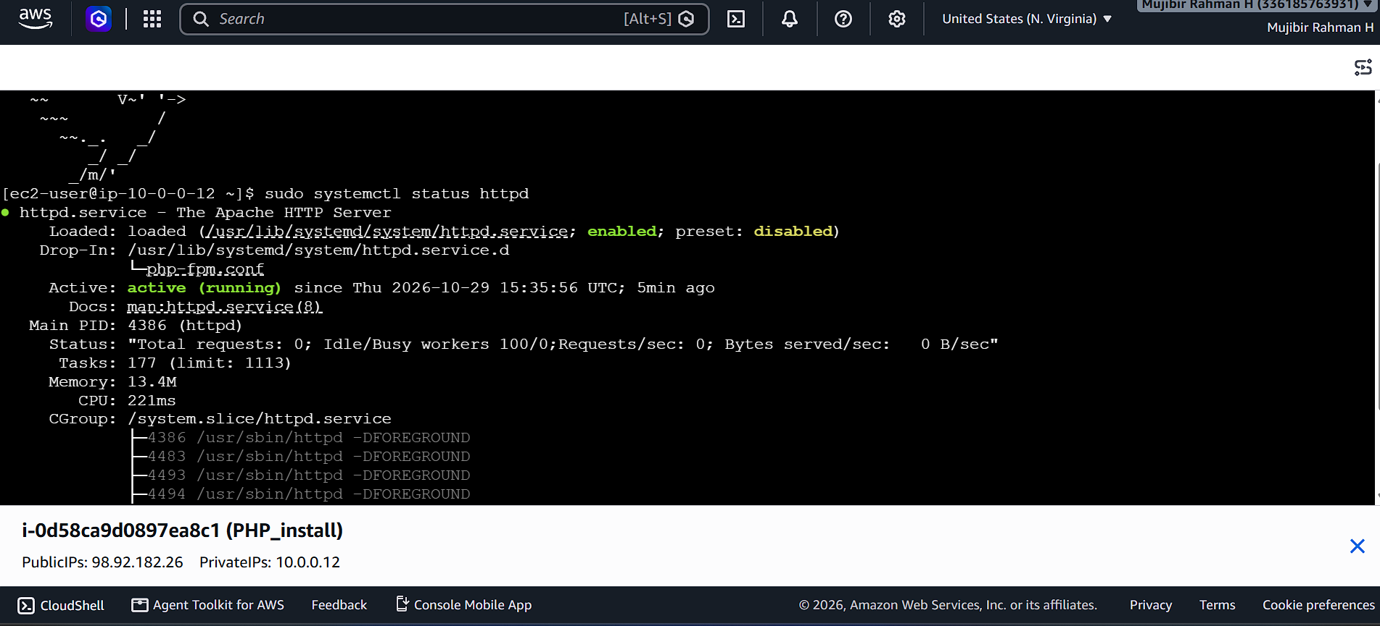
- Configure NAT gateway in public subnet and connect to private instance.
I created one VPC, two subnets, two route tables, One IGW, Two Security group.
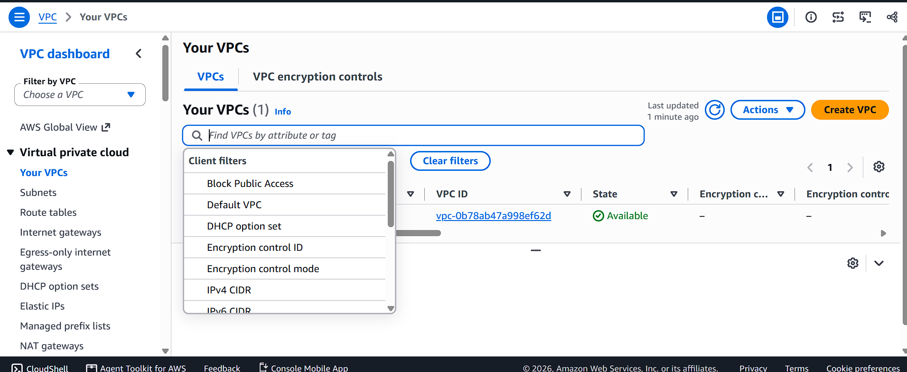
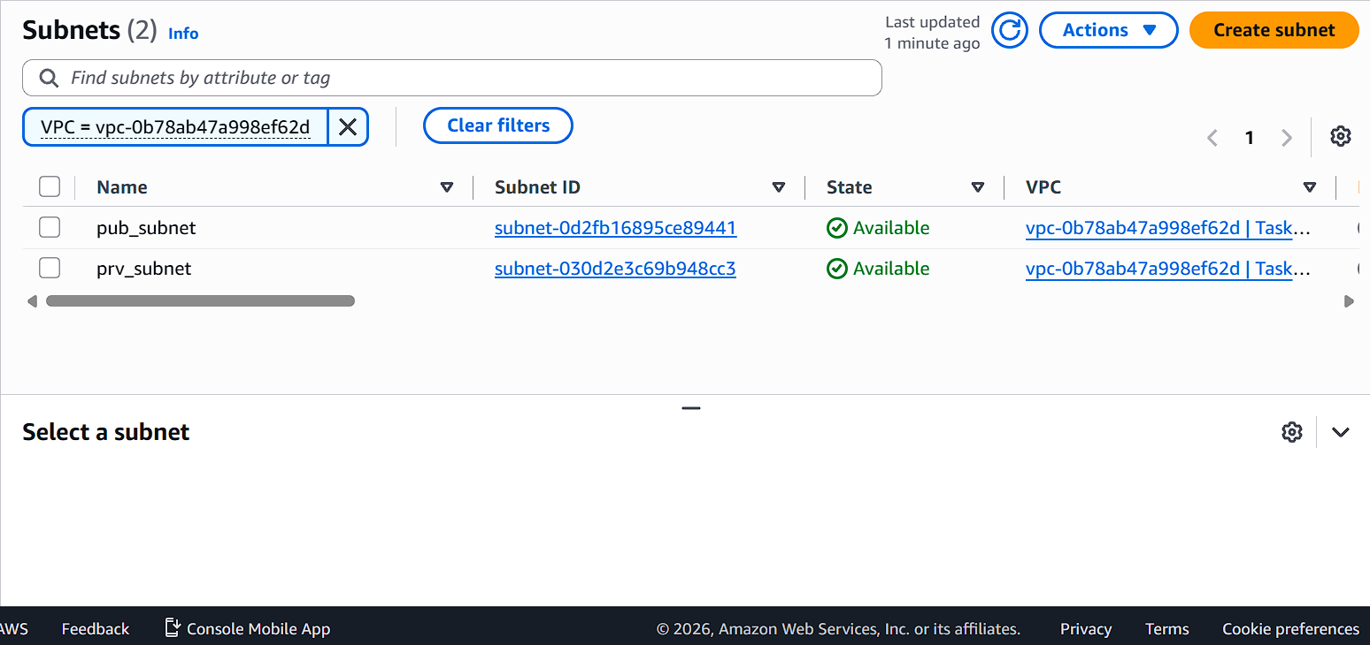
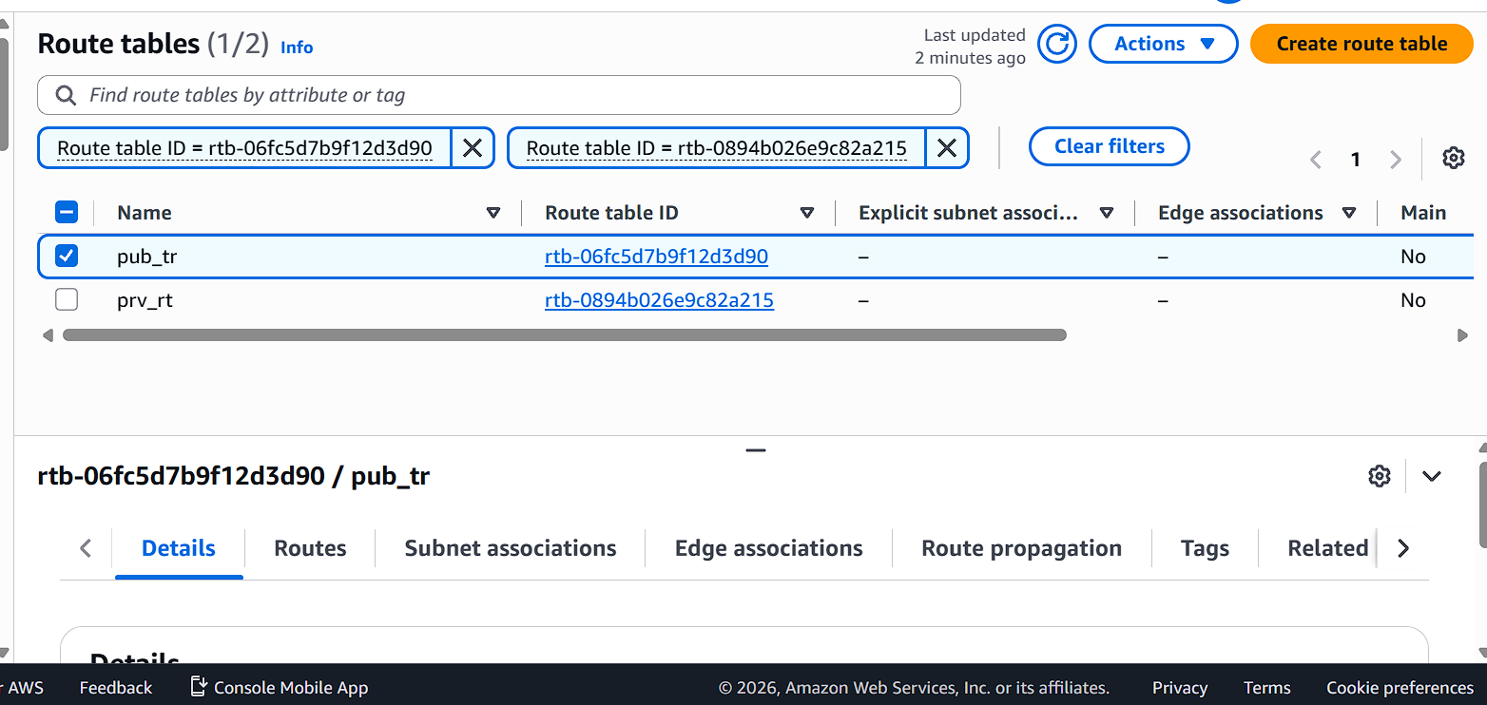
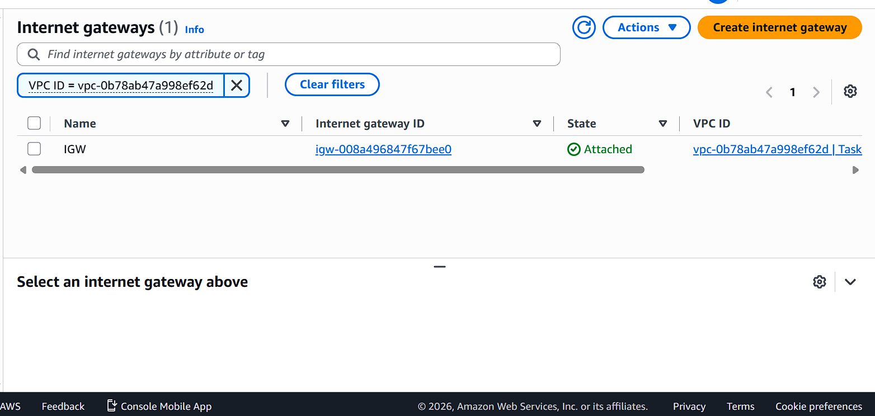
Given the IGW to public subnets
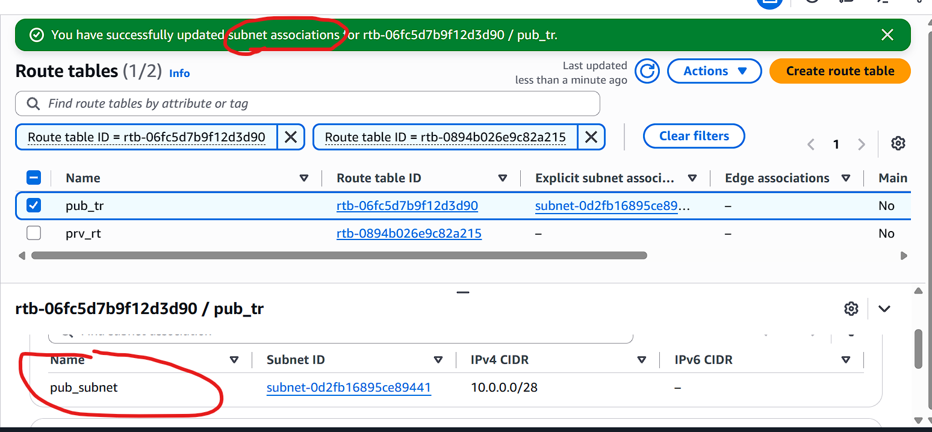
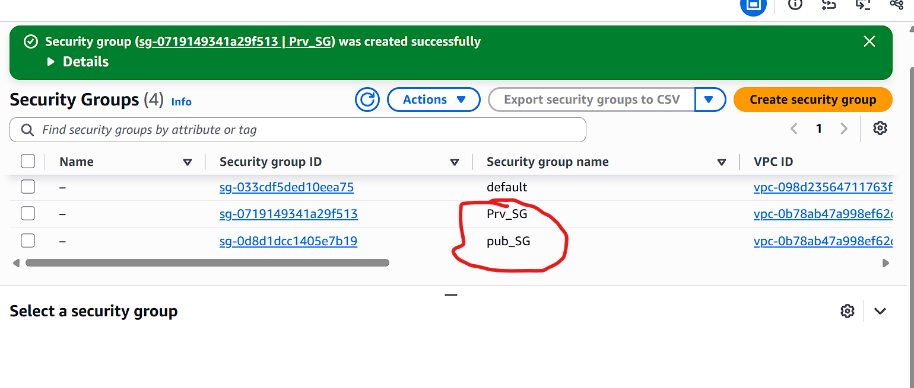
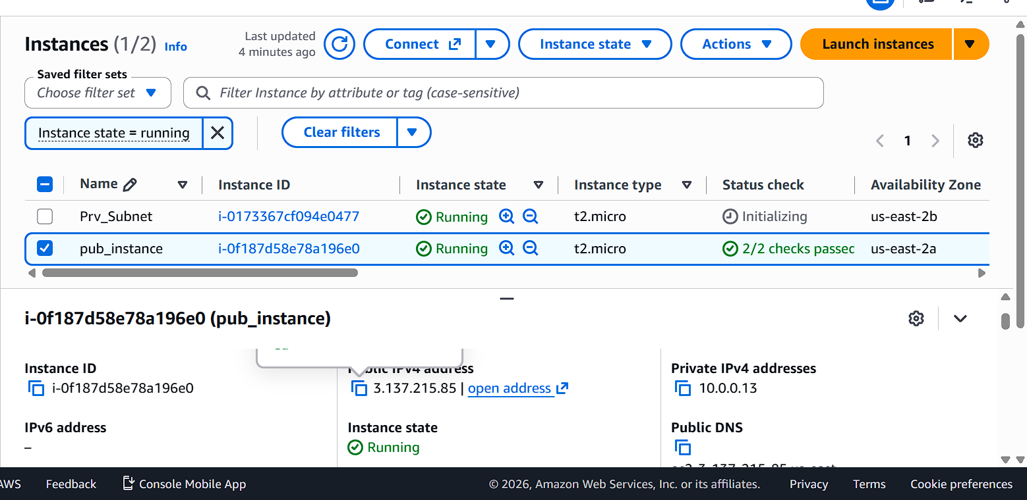
Public Instance is created and connected from local.
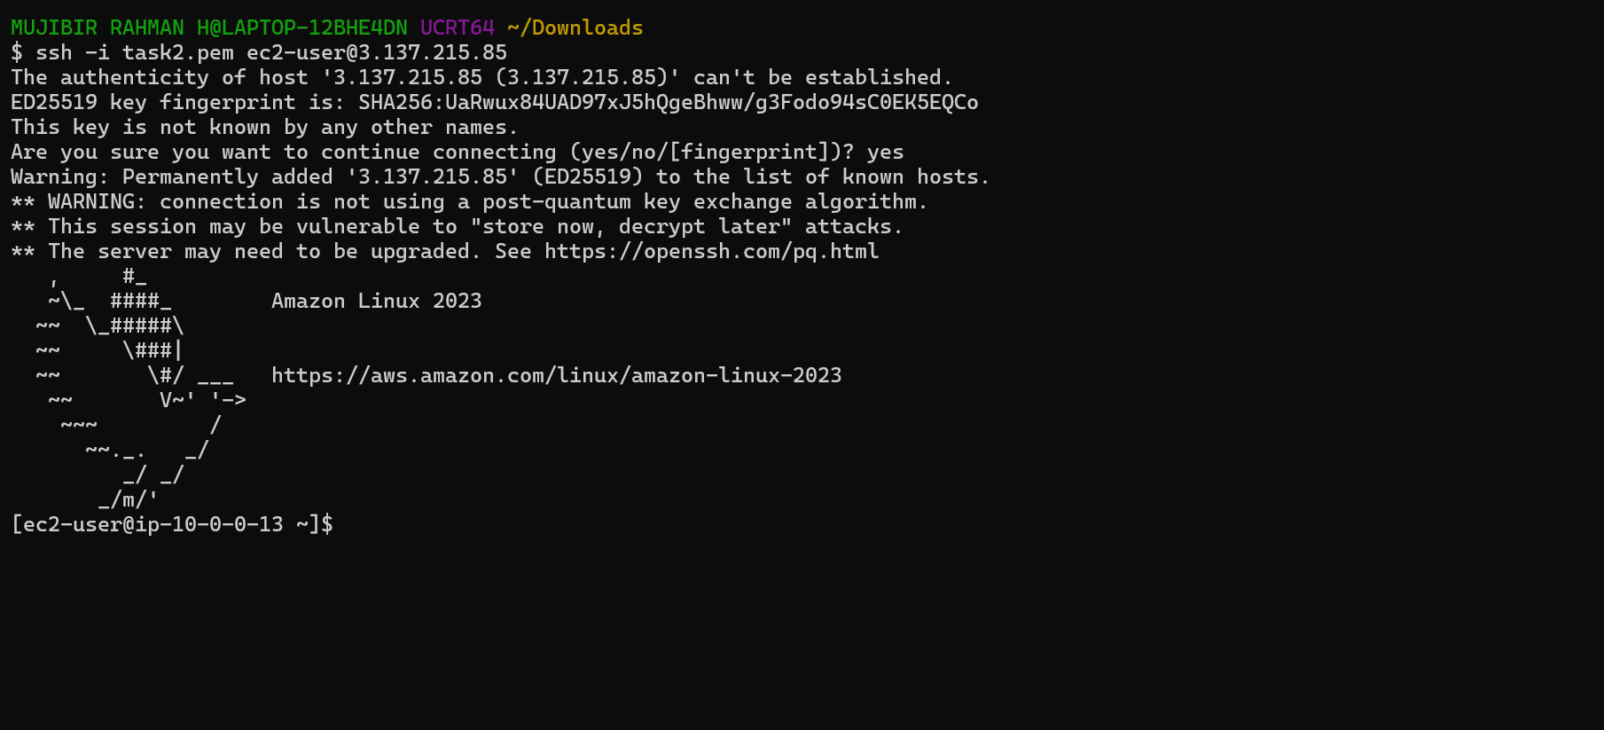
Private instance didn’t connected . Because there is no IGW attached.
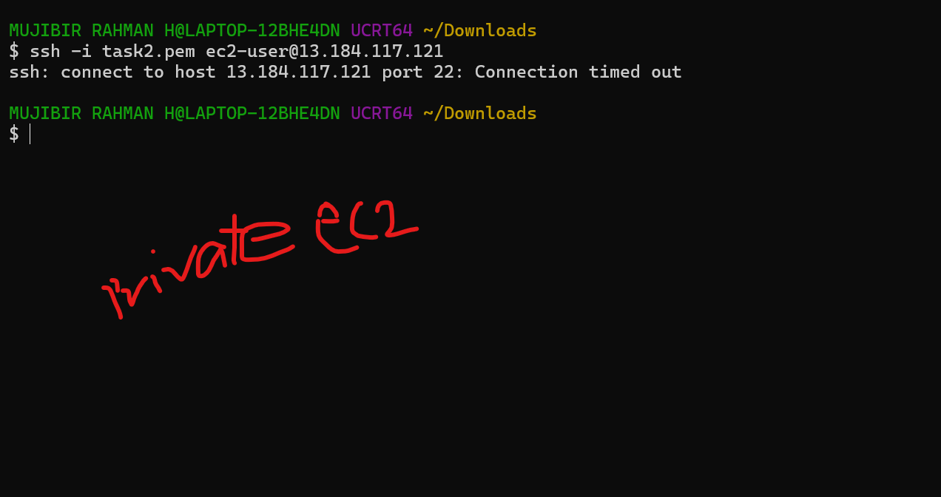
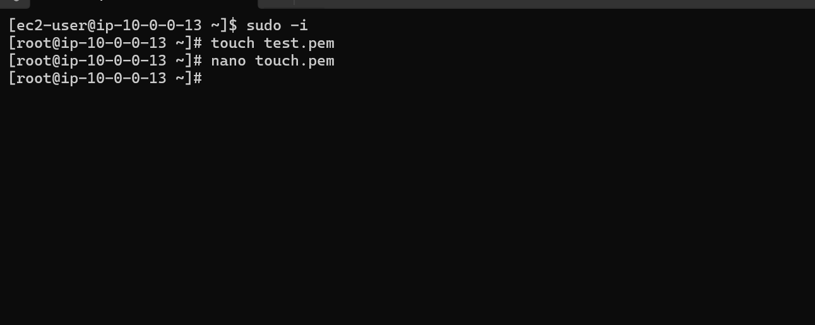
I created one file and pasted my pem key to this file. And tried to connect from public instance to private. It’s connected.
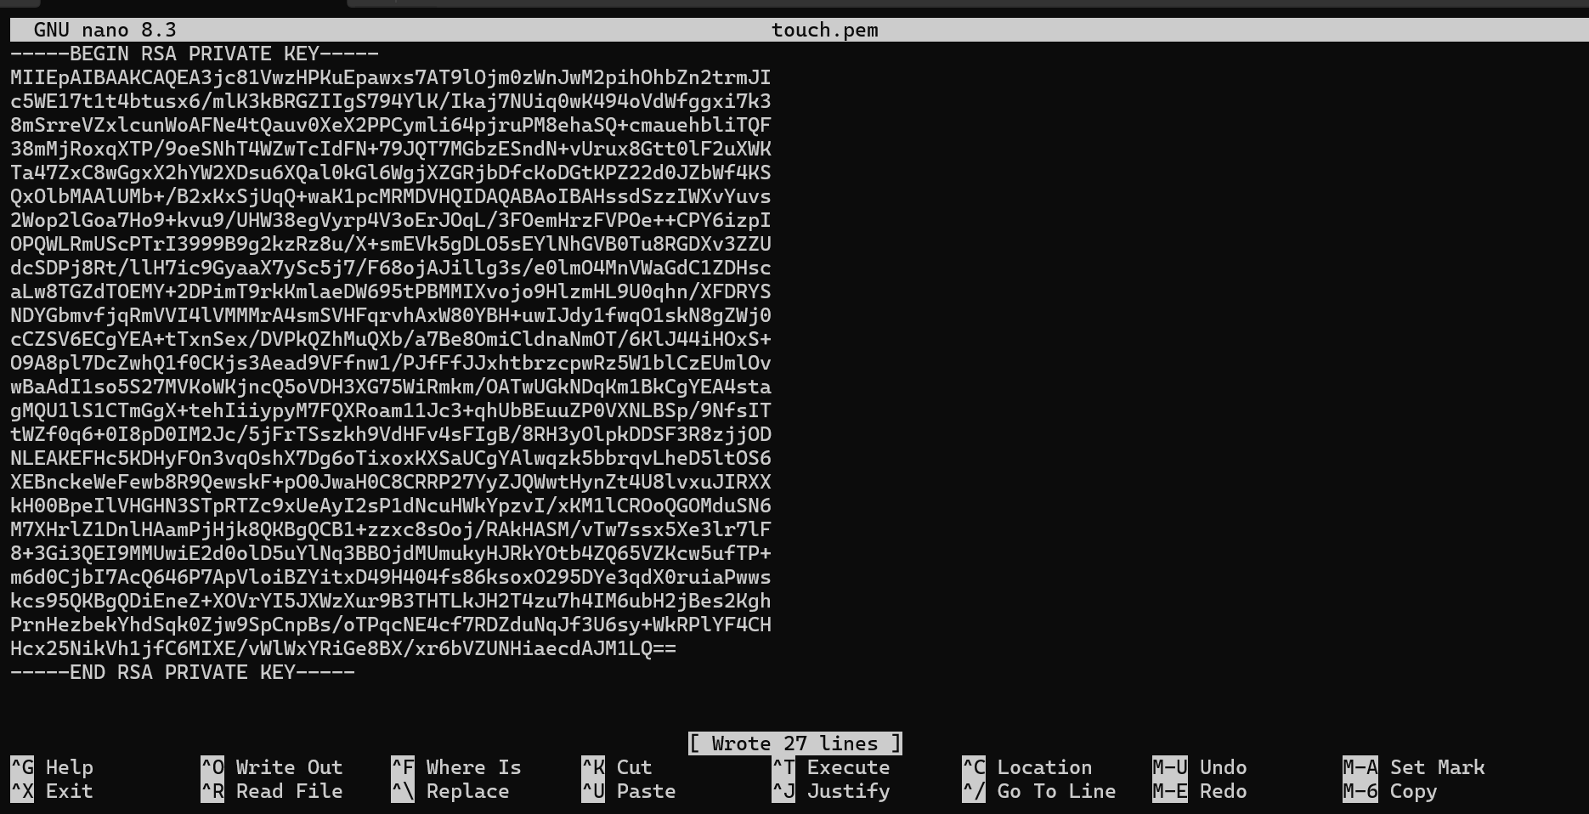
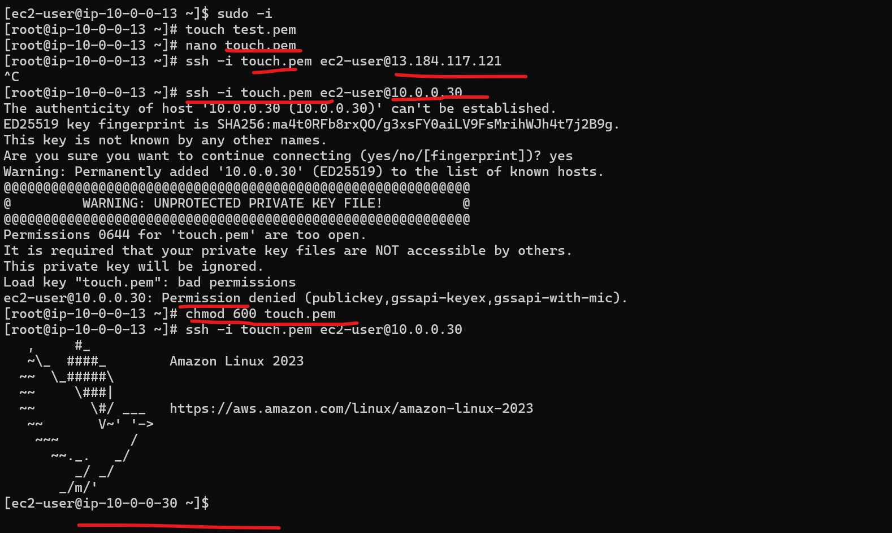
I created a one NAT Gateway and selected the public subnet. For accessing the internet in private instance. Before we just connected to private instance from public.
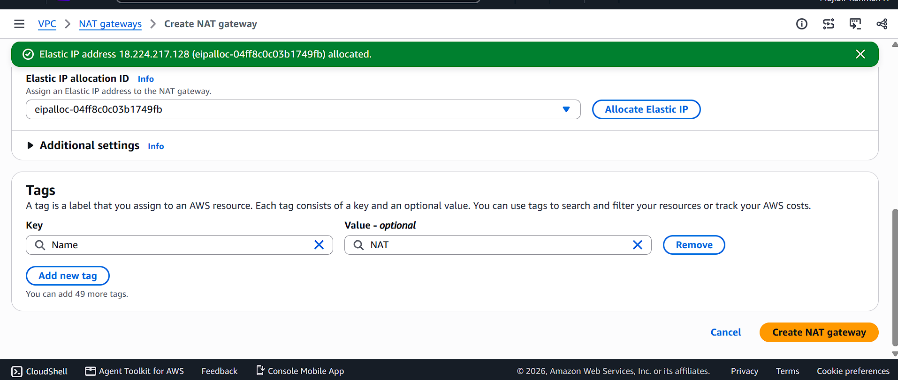
Added the NAT gateway in that private instance. Now we are accesing the internet from NAT gateway (Borrowing internet from public instance).
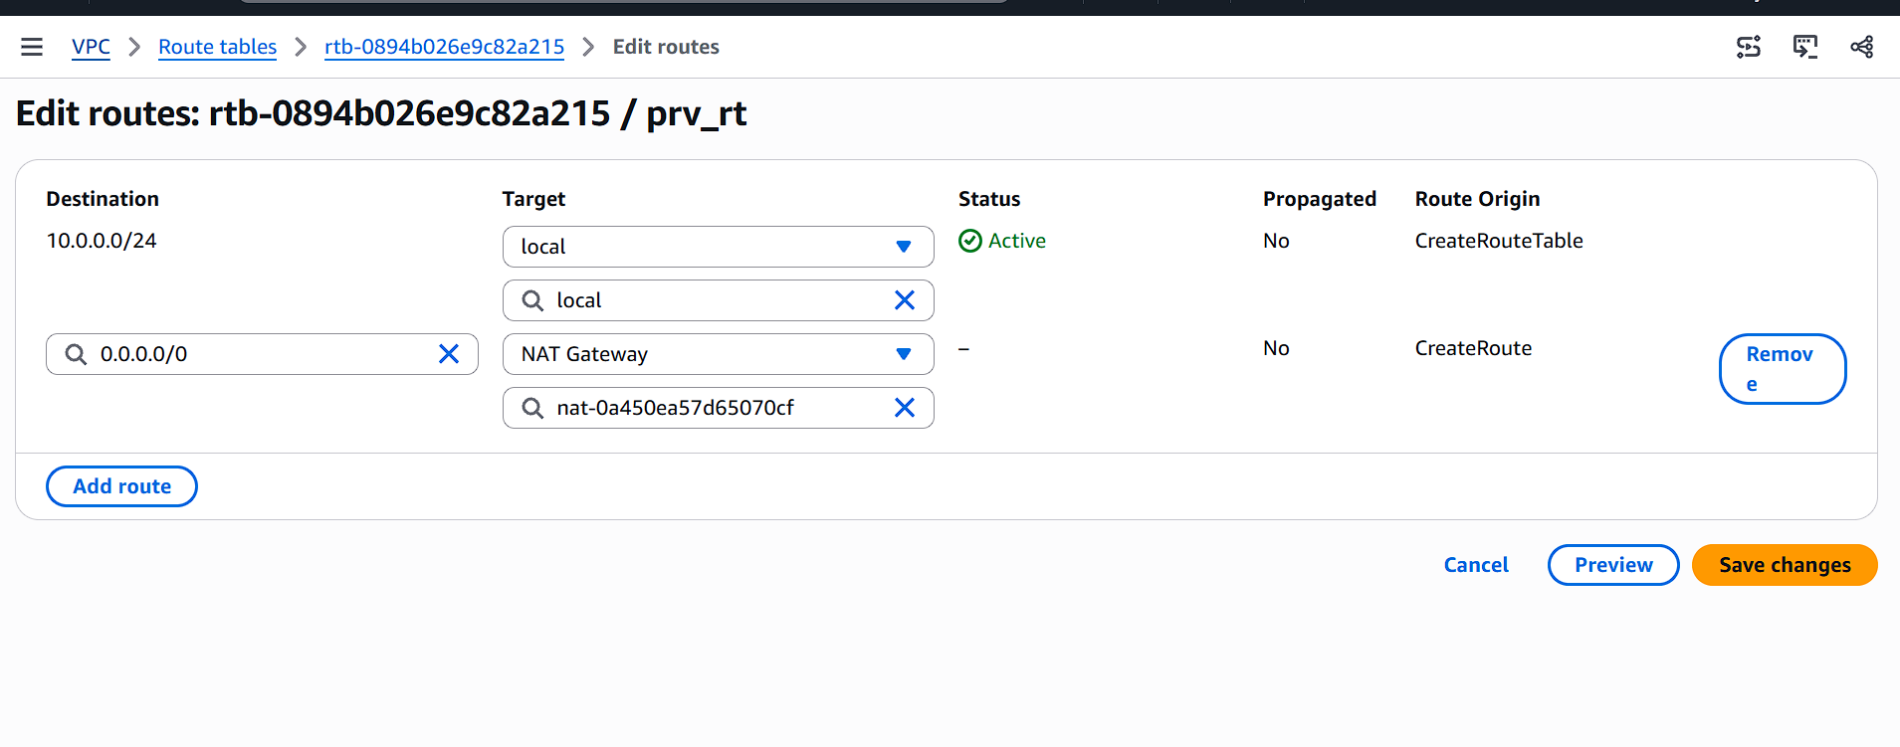
Now I just entered my private instance and checked the internet. It’s working.
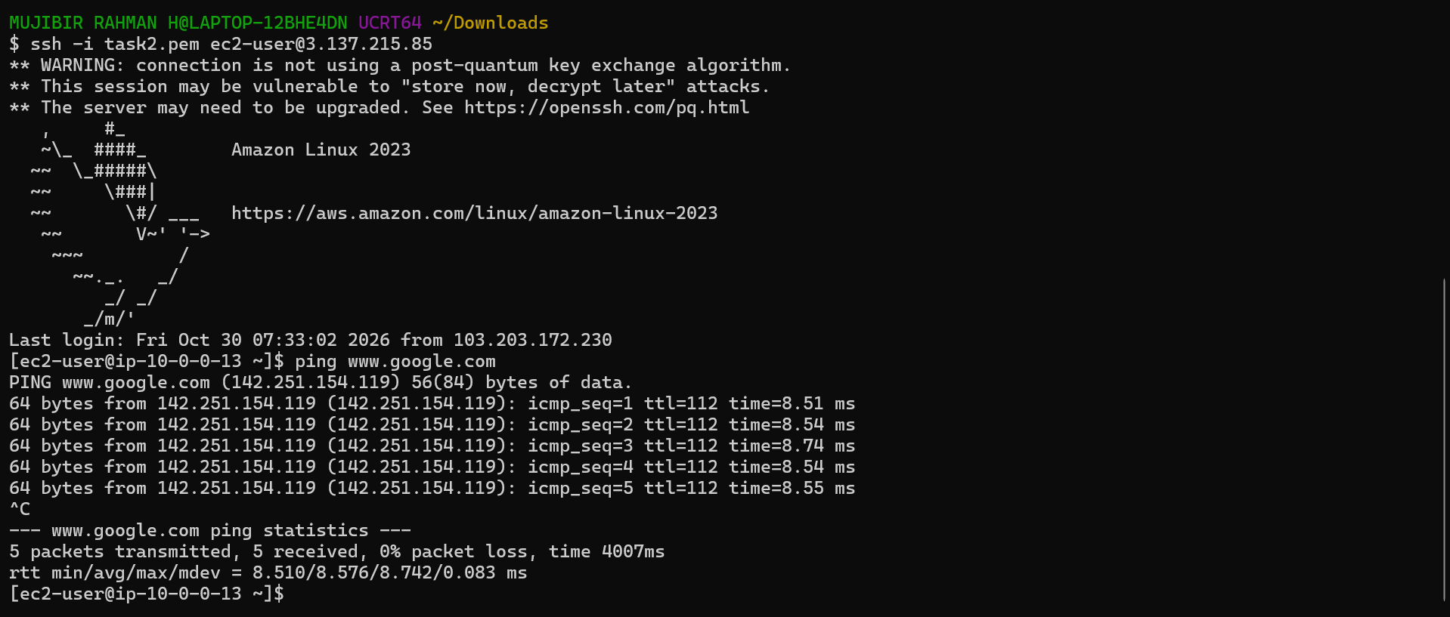
- Install Apache Tomcat in private EC2 and deploy a sample app.
I just installed the java and tomcat manually in the private Instance which I already connected through jump host.
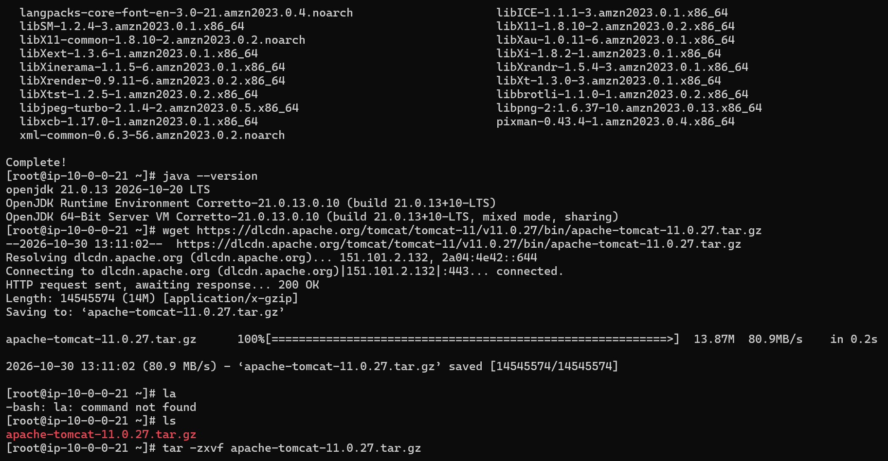
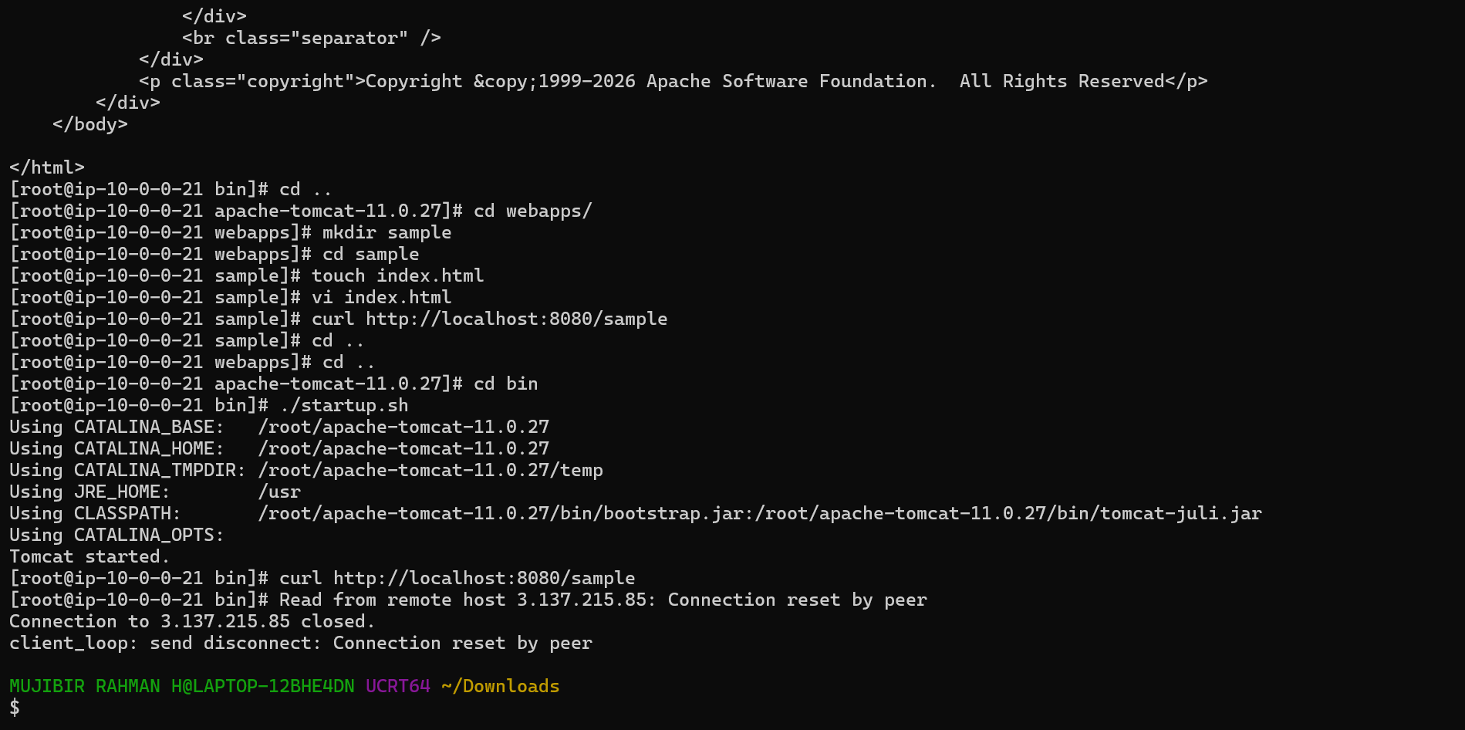
- Configure VPC flow logs and store the logs in S3 and CloudWatch.


